Chapter 5

# Try It Yourself: Filter Using a Wildcard

## Excel Instructions

1. Open Customers.csv in Excel.
2. How many observations from the **Customers** table have a contact name (ContactName) that starts with a “Z”?
   1. Verify the first row of Column C is ContactName.
   2. Highlight all of Column C.
   3. From the Excel ribbon at the top of the window, select ‘Data’ → ‘Filter’. This action will enable a dropdown arrow at the header of Column C.
   4. Click the dropdown arrow in Column C's ContactName column header.
   5. Choose ‘Text Filters’ → ‘Begins With…’

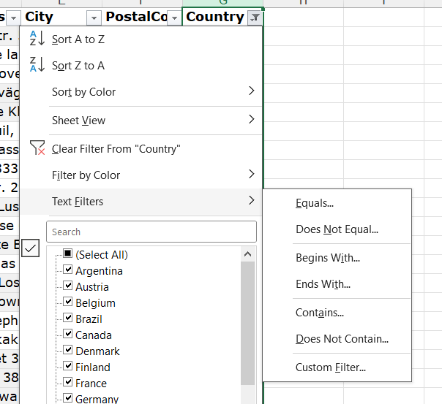

* 1. Type “Z” into the text box.
  2. Click OK.

1. How many observations from the **Customers** table have a customer name (CustomerName) that starts with a “B”?
   1. Open the dropdown next to ContactName, and select “Clear Filter from ‘ContactName’”. This will clear filters from Step 2.
   2. Repeat the steps in #2, except this time filter CustomerName (column B). Type “B” into the text box instead of “Z” in step (g).
   3. Remember not to count the header when counting your observations.
2. How many observations from the **Customers** table have a customer name (CustomerName) that ends with a “B”?
   1. Open the dropdown next to CustomerName, and select “Clear Filter from CustomerName”. This will clear filters from Step 3.
   2. Repeat #2 steps for CustomerName (column B) except:
      1. In step (f), choose ‘Text Filters’ → ‘Ends With…’
      2. In step (g), type “B”.